How to disable optimization when building WRK for easily debug? I just tell ‘HOW TO’ but not tell ‘WHY’; if having tried to do so, you may already know ‘WHY’.

**1. Build AMD64 WRK**

a) Edit \BASE\NTOS\BUILD\MAKEFILE.BUILD

targcopts = -Wp64 **-Zi -Od** -EHs-c- **/Od** -Gs12288 -GL- -MT -U_MT

b) Edit \BASE\NTOS\PERF\HOOKS.C, implement function **abs(…)** at line 405 by yourself. For example,

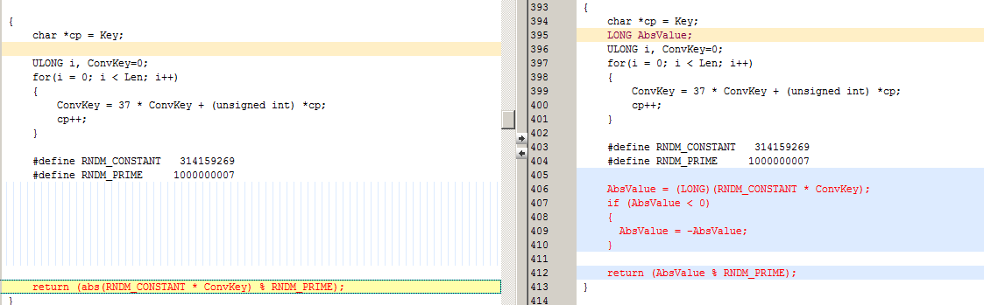

c) Build with command ‘nmake –nologo amd64=’

**2. Build X86 WRK**

1) First build X86 WRK with optimization on

2) Copy \BASE\NTOS\RTL\BUILD\OBJI386\**bitmap.ob**j out for later use

3) Clean with command ‘nmake x86= clean’

4) Edit \BASE\NTOS\BUILD\MAKEFILE.BUILD

targcopts = -Gm- -Gz -GX- -G6 -Ze -Gi- -QIfdiv- **-Zi -Od** -Oy-

5) Copy **bitmap.obj** to \BASE\NTOS\RTL\BUILD\OBJI386\**bitmap.obj**

6) Build with command ‘nmake –nologo x86=’

I debugged AMD64 WRK with optimization off in 64bit win03sp2, it worked fine. Good luck!